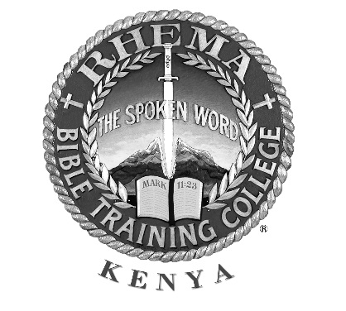
Rhema Bible Training College Kenya
Box 411 Mtwapa – 80109 │Phone 0728 141513 │www.rhemakenya.org

APPLICATION FORM – 2nd YEAR

Instructions: Complete this form and return it with one recent passport size photograph. Answer all questions, if the question does not apply, fill in N/A. Ensure that your recommendation form has been promptly returned to enable the processing of your application.
- BASIC INFORMATION

- Name (As in the national ID)

_{Surname} _{First Name} _{Middle Name}

- Contacts: (The most preferable means of communication is via email)
- P. O. Box/Street Address
- City/Town
- Postal Code
- Country
- Email
- Mobile Phone

- Gender Male Female

- Date of Birth
_{Day} _{Month} _{Year}

- Nationality Kenyan Other (Specify)

- Nearest Relative (Not Spouse) to be notified incase of emergency; Must have a phone.

Name Relationship
Residential Address
Mobile Phone

- MARITAL STATUS INFORMATION
- Single Engaged Widow(er) Separated Divorced Remarried
Married with certificate Married without Certificate
- Date Married with Certificate
- Spouse/Fiancé (e) Details. Name
- Spouse Mobile Phone
- Have your Spouse been previously married? Yes No
- SPIRITUAL DETAILS
- Have you been Born Again (Saved) Yes No
If Yes, state when and where?
Briefly explain how you got saved:

- Have you been baptised as a believer by immersion in water? Yes No
If Yes, when and where were you baptised (immersed) in water? Place

- Have you been baptised in the Holy Spirit with the evidence of speaking in tongues as in Acts 2:4? Yes No If yes, state date and place.
Briefly describe how it happened:

- Fundamental Beliefs
Do you believe that the Bible is God’s inspired Word and the only infallible guide in matters of conduct and in doctrine? Yes No
Do you believe in the Trinity, that God is one, but manifested in three persons: Father, Son, and Holy Spirit? Yes No
Do you believe in the deity of Jesus Christ, that He is God made flesh and the only Mediator between God and man? Yes No

- Have you been counselled in the last 2 years concerning personal or family issues?
Yes No
If Yes, explain briefly:

Who was the counsellor?
- CHURCH MEMBERSHIP
- Name of your current local church
Town or City
Name of the Pastor
Denomination of current local church
- How long have you been attending this church
- What church activities are you currently involved in?
- If you are not currently involved in a church, please explain why.

- MINISTERIAL DETAIL
- Do you at this moment have the call of God to enter the ministry?
Yes No Not Sure

- EDUCATION
- Can you read, write and comprehend the English language? Yes No
- Can you read, write and comprehend the Swahili language? Yes No
- Tick your successfully completed level of education.
Primary Secondary Vocational/Technical College/University

- RECOMMENDATION
- Who is completing your recommendation form?

Title Name
Relationship Phone

- DECLARATIONS
- Why do you want to attend Rhema Bible training College?

- STATEMENT OF TRUTH
I hereby state that all the information submitted in this application is correct and true. If Rhema Kenya is notified that any of the information contained herein is false, it will be justified grounds for my dismissal.

Signature Date

